**Fiji (ImageJ) Method for counting cell(s)**

Step 1: upload the Original image



Step 2: Remove background noise of image



Step 3: Make the image Binary (BW) and apply watershed



Step 4: Apply threshold and modify the image



Step 5: Use Analyze particles to identify each objects of the image



Step 6: extract the area of each individual cell area into excel worksheet

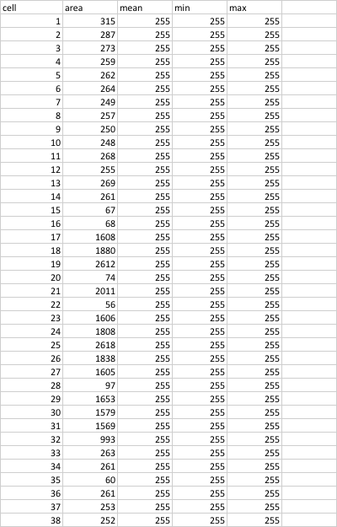

Step 7: Read excel worksheet data and count total cells using MATLAB

% Counting cells from image-J data

clc;

close all;

m_area= 120;                    % mother cell area

d_area = 90;                    % daughter cell area

data= xlsread('area.xlsx');     % import cell data fron image-J

cell= data(:,1);                % 1st column is cell's number

area = data(:,2);               % 2nd column is cell's area

%plot(cell,area < m_area)

count_M_cell= sum(area < m_area) % total number of cell cooresponding to mother  cells

count_D_cell= sum(area < d_area) % total number of cell cooresponding to daugther  cells

count_M_cell =

142

count_D_cell =

126

Step 8: Compare the result with manual reading



Step 9: Compare the original image with analyzed image from Fiji and identify errors



